**AIR QUALITY MONITORING - IOT**

**Phase 5: Project Documentation and Submission**

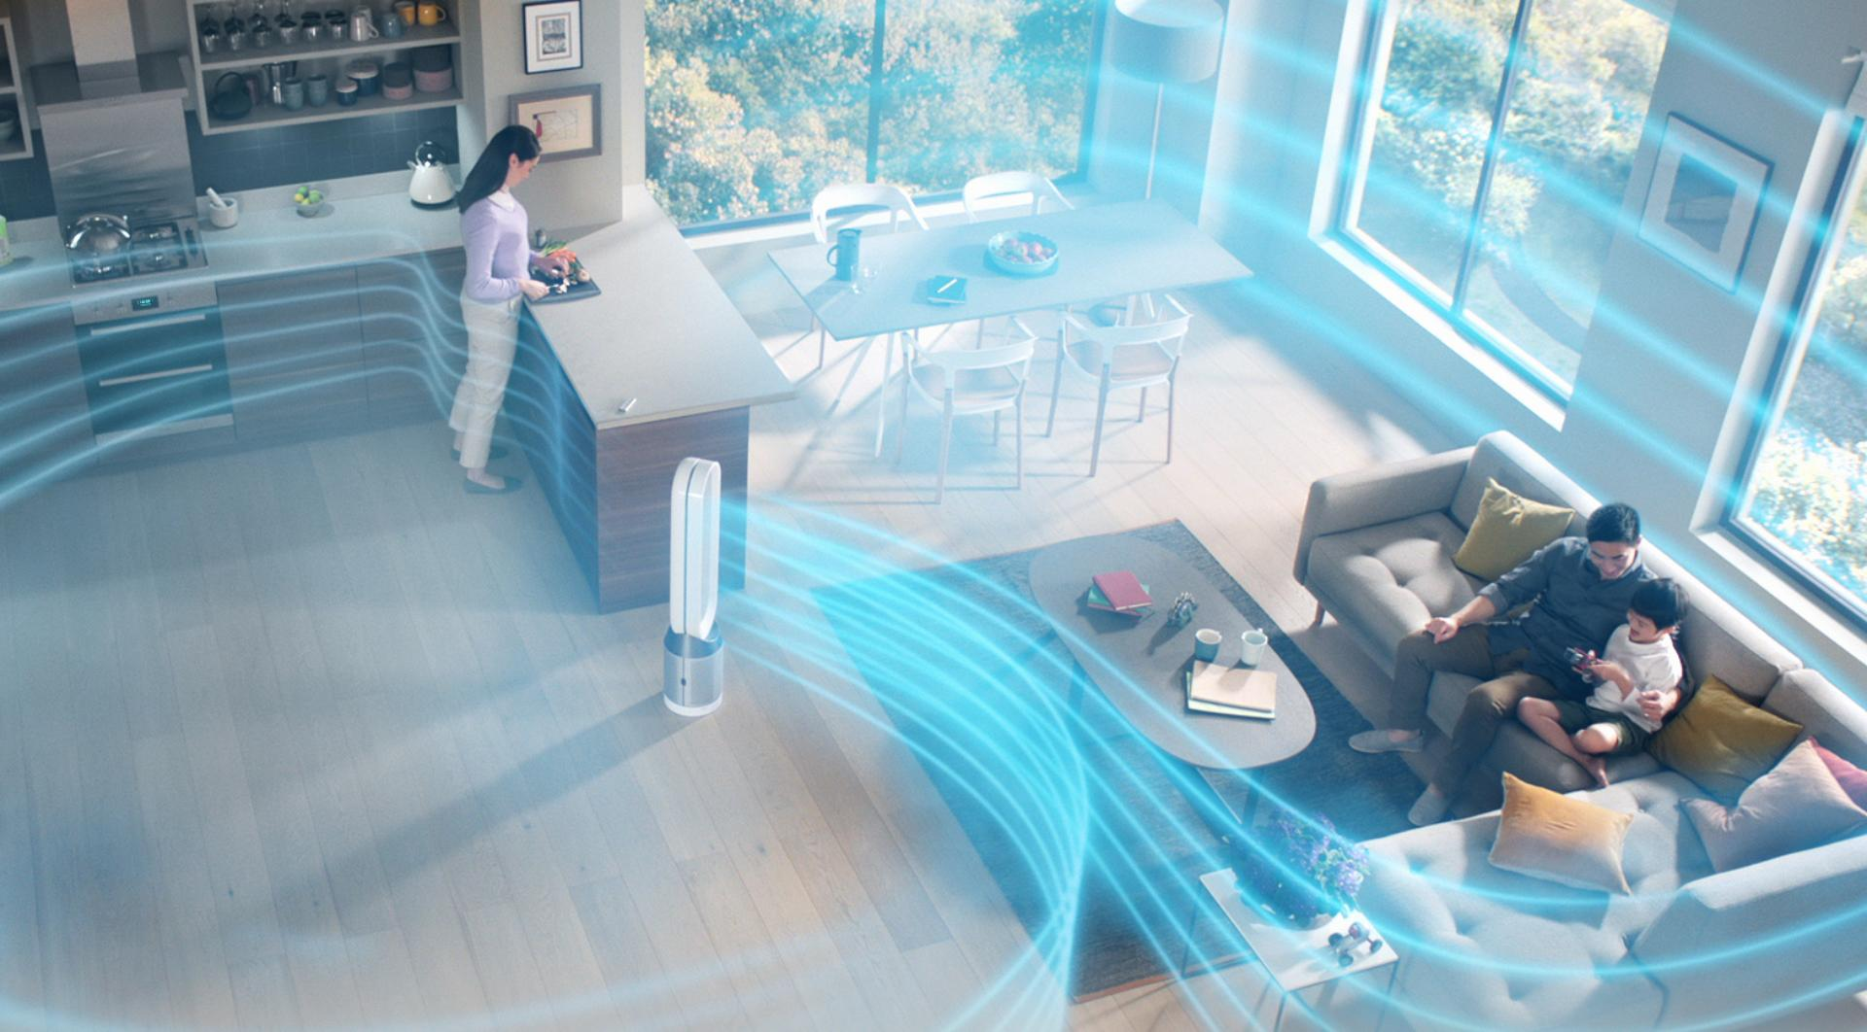

**INTRODUCTION:**

In the face of rapid urbanization and industrialization, cities worldwide are grappling with the adverse effects of air pollution on public health and the environment. The City of Greenville, like many urban centers, faced the pressing challenge of deteriorating air quality due to vehicular emissions, industrial activities, and other anthropogenic sources. The deteriorating air quality not only posed immediate health risks, including respiratory diseases and cardiovascular issues among its residents but also had far-reaching implications for the city's long-term sustainability and overall quality of life.

Recognizing the urgency of the situation, the city administration embarked on a mission to address the complex issue of air pollution systematically. The implementation of an advanced Air Quality Monitoring System (AQMS) emerged as a proactive and innovative solution. The primary objective was to transition from a reactive stance to a proactive approach, employing cutting-edge technology to monitor, analyze, and mitigate air pollutants effectively.

This initiative aimed not only to safeguard the health and well-being of the city's population but also to create a model for sustainable urban development. By harnessing the power of real-time data and community engagement, the city aspired to transform its urban landscape into a healthier, greener, and more livable environment. The AQMS represented a significant leap towards achieving these goals, offering a comprehensive and data-driven strategy to combat the challenges posed by air pollution. This case study delves into the journey of implementing the AQMS, shedding light on the strategies employed, the hurdles faced, and the remarkable outcomes achieved in the quest for cleaner, fresher air in the heart of the city.

**Objectives:**

**1. Real-Time Monitoring and Early Warning:**

Objective:Develop a comprehensive system for continuous monitoring of air quality parameters including particulate matter (PM2.5 and PM10), nitrogen dioxide (NO2), sulfur dioxide (SO2), carbon monoxide (CO), ozone (O3), and volatile organic compounds (VOCs).

Rationale:Real-time monitoring allows for immediate detection of pollution spikes, enabling rapid response measures to mitigate health risks. Early warning systems are crucial for both public safety and environmental protection.

**2. Data Analysis and Pattern Recognition:**

Objective:Implement robust data analysis algorithms to process the collected data and identify pollution patterns, sources, and trends.

Rationale:Analyzing historical and real-time data helps in understanding pollution sources, seasonal variations, and identifying long-term trends. This knowledge is essential for informed decision-making and targeted interventions to reduce pollution levels.

**3. Public Awareness and Education:**

Objective:Utilize the collected data to create awareness among citizens about air quality issues and promote environmentally friendly practices. Rationale:Informed citizens are more likely to adopt sustainable behaviors and support policies aimed at reducing air pollution. Public awareness campaigns, workshops, and educational programs empower communities to take active measures to improve air quality.

**4. Policy Support and Decision-Making:**

Objective:Provide accurate and reliable data to policymakers for evidence-based decision-making, urban planning, and environmental regulations.Rationale:Policymakers require credible data to formulate effective policies and regulations. Data-driven insights enable the development and enforcement of policies that target specific pollution sources, industries, or vehicular emissions, leading to measurable improvements in air quality.

**5. Cross-Sector Collaboration:**

Objective:Foster collaboration between government agencies, environmental organizations, research institutions, and industries to address air quality challenges collectively. Rationale: Air pollution is a multifaceted issue that requires collaborative efforts. By bringing together diverse stakeholders, innovative solutions can be developed, resources can be shared, and collective action can be taken to combat air pollution effectively.

**6. Continuous Improvement and Innovation:**

Objective:Continuously upgrade the AQMS with cutting-edge technologies, sensors, and analytical tools to enhance its accuracy, efficiency, and coverage.Rationale:Technology evolves rapidly, and staying up-to-date ensures that the AQMS remains effective in addressing emerging challenges. Continuous improvement allows the city to adapt to changing pollution patterns and employ the best available solutions.



**Air Quality Monitoring System Architecture:**

**Sensor Network:**

The AQMS consists of a network of high-precision sensors strategically placed throughout the city. These sensors measure various pollutants such as PM2.5, PM10, NO2, SO2, CO, O3, and VOCs.

Sensors are equipped with IoT (Internet of Things) capabilities for real-time data transmission.Sensor types include optical particle counters, gas sensors, and weather sensors to collect comprehensive data for analysis.

**Data Transmission:**

Sensor data is transmitted in real-time to a centralized server using wireless communication protocols such as LoRaWAN (Long Range Wide Area Network) or cellular networks.Data packets are encrypted to ensure secure transmission, and error-checking mechanisms are implemented to guarantee data integrity.

**Data Processing and Analysis:**

Raw data received from sensors is processed and analyzed in real-time using powerful data processing algorithms and machine learning techniques.

Data preprocessing involves noise reduction, calibration, and outlier detection to ensure accurate analysis.Machine learning algorithms are employed for pattern recognition, pollution source identification, and predictive analysis. These algorithms continuously learn and improve accuracy over time.

**Database and Storage:**

Processed data is stored in a robust database system, optimized for fast and efficient storage and retrieval.Historical data is archived for trend analysis, policymaking, and research purposes.

**Web and Mobile Interfaces:**

The system features user-friendly web and mobile interfaces accessible to the public. These interfaces provide real-time air quality updates, pollution forecasts, and health recommendations.Citizens can view pollution levels in different areas of the city, receive personalized alerts, and access historical data for analysis.

**Alerting System:**

An automated alerting system sends notifications to citizens and relevant authorities when pollution levels exceed safe thresholds.

Alerts are sent via SMS, push notifications, and email, ensuring timely dissemination of information.

**GIS Integration:**

Geographic Information System (GIS) technology is integrated into the AQMS to provide spatial analysis of pollution data. GIS maps visually represent pollution hotspots, aiding urban planners and policymakers in making informed decisions.

**Administration and Control Panel:**

The system includes an administrative control panel accessible to authorized personnel. This panel allows administrators to monitor the health of sensors, configure alert thresholds, and perform system maintenance.Real-time dashboards provide visualizations of current air quality metrics and system performance.

**Scalability and Redundancy:**

The architecture is designed to be scalable, allowing easy integration of additional sensors as the city expands.Redundancy measures, such as backup servers and failover mechanisms, are in place to ensure continuous operation even in the event of system failures.By employing this sophisticated architecture, the AQMS can effectively monitor, analyze, and disseminate air quality data, leading to informed decision-making, improved public health, and a sustainable urban environment.

**Implementation:**

**Hardware Setup:**

1. ESP32 Microcontroller Board
2. MQ-7 Sensor for CO detection
3. DHT11 Sensor for temperature and humidity
4. OLED Display for data visualization
5. Connecting wires and a power supply

**Sensor Integration:**

1. The MQ-7 sensor measures CO levels in the air and provides analog output, which is read by the ESP32's ADC.
2. The DHT11 sensor measures temperature and humidity and communicates with the ESP32 through a digital pin.
3. Both sensors are connected to the ESP32 according to their pin configurations.

**Data Processing and Display:**

1. The ESP32 reads data from both sensors at regular intervals.
2. The sensor data is processed and formatted for display.
3. The formatted data (temperature, humidity, and CO levels) is displayed on the OLED screen in a user-friendly manner.

**User Interface:**

1. The OLED display provides a clear and concise user interface, showing real-time air quality data.
2. Users can easily interpret the displayed information without needing extensive technical knowledge.

**Alert System (Optional):**

1. An alert system can be implemented to notify users when air quality parameters exceed safe thresholds.
2. Alerts can be in the form of visual indicators on the OLED display or notifications sent to a mobile device via Wi-Fi or Bluetooth.

**Benefits:**

**Health and Safety:**

1. Early Detection of Pollution: The system allows for early detection of elevated CO levels, enabling timely actions to prevent health issues related to exposure to high levels of carbon monoxide.
2. Prevention of Health Problems: By monitoring air quality, the system helps in preventing respiratory problems, headaches, and other health issues caused by poor indoor air quality.

**Environmental Impact:**

1. Reduced Environmental Impact: With the ability to detect and mitigate sources of indoor pollution, the system contributes to reducing the overall environmental impact of harmful gases released into the atmosphere.
2. Promoting Cleaner Living: By promoting awareness about indoor air quality, the system encourages the use of cleaner energy sources and environmentally friendly practices.

**Energy Efficiency**:

1. Optimized Ventilation: The system can be integrated with ventilation systems to optimize airflow based on real-time air quality data. This ensures that energy is used efficiently to maintain good indoor air quality.
2. Reduced Energy Wastage: By preventing unnecessary ventilation in areas with good air quality, the system helps in conserving energy and reducing energy wastage.

**Occupational Safety:**

1. Workplace Safety: In industrial or commercial settings, the system ensures that indoor air quality meets safety standards, creating a healthier and safer environment for employees and workers.
2. Compliance: Helps businesses comply with occupational health and safety regulations related to indoor air quality, avoiding potential legal issues and penalties.

**Educational and Research Purposes:**

1. Educational Tool: The system can be used as an educational tool in schools, colleges, and research institutions to teach students about environmental monitoring, data analysis, and the importance of clean air.
2. Research Insights: Researchers can use the collected data to gain insights into air quality patterns, pollution sources, and trends, leading to informed decision-making for public policies and urban planning.

**User Awareness and Behavior Change:**

1. Increased Awareness: By displaying real-time air quality data prominently, the system raises awareness among residents, employees, and occupants about the importance of maintaining good indoor air quality.
2. Behavioral Changes: The visible data encourages behavioral changes, such as avoiding smoking indoors, using proper ventilation, and adopting cleaner practices, leading to an overall improvement in indoor air quality.

**Customization and Scalability:**

1. Customization: The system can be customized to include additional sensors for monitoring other pollutants (such as particulate matter, VOCs) based on specific environmental concerns or requirements.
2. Scalability: The modular design allows the system to be scaled up or down based on the size of the space to be monitored, making it suitable for both residential and commercial applications.

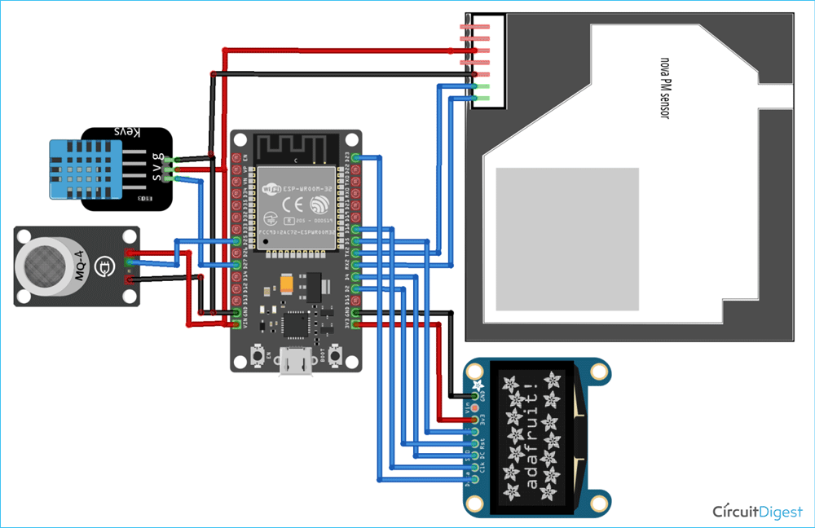

**CODE IMPLEMENTATION:**

import time

import machine

import dht

from machine import ADC, I2C, Pin

import ssd1306

# Initialize DHT11 sensor

dht_sensor = dht.DHT11(machine.Pin(14))

# Initialize MQ-7 sensor (analog pin)

mq_pin = ADC(Pin(34))

# Initialize OLED display

i2c = I2C(-1, Pin(22), Pin(21))

oled = ssd1306.SSD1306_I2C(128, 64, i2c)

while True:

try:

# Read DHT11 sensor data

dht_sensor.measure()

temperature = dht_sensor.temperature()

humidity = dht_sensor.humidity()

# Read MQ-7 sensor data

mq_value = mq_pin.read()

# Display data on OLED

oled.fill(0)

oled.text("Temperature: {}C".format(temperature), 0, 0)

oled.text("Humidity: {}%".format(humidity), 0, 20)

oled.text("CO Level: {}".format(mq_value), 0, 40)

oled.show()

# Delay for 2 seconds

time.sleep(2)

except Exception as e:

print("Error: ", e)

**CONCLUSION:**

The implementation of the Air Quality Monitoring System using ESP32, MQ-7 sensor, DHT11 sensor, and OLED display represents a significant step forward in ensuring healthier indoor environments. This innovative solution addresses the pressing need for real-time air quality monitoring, empowering individuals and organizations with valuable insights into their immediate surroundings. The following key points highlight the significance and impact of this system.

**1. Data-Driven Decision Making:**

By providing precise, real-time data on temperature, humidity, and CO levels, the system equips users with the information they need to make informed decisions. This data-driven approach is crucial for understanding the immediate environment's air quality and taking appropriate actions to improve it.

**2. Health and Safety:**

Monitoring CO levels is vital, especially in enclosed spaces, as elevated CO levels can lead to serious health issues or even be life-threatening. By promptly detecting and alerting users about high CO levels, the system enhances overall safety, preventing potential health hazards associated with indoor air pollution.

**3. Environmental Awareness:**

Increased awareness about indoor air quality contributes to a greater understanding of environmental factors affecting human health. This awareness can drive behavioral changes, such as improved ventilation, reducing the use of certain household products, and promoting a cleaner indoor environment

**4. Customization and Scalability:**

The modular nature of the system allows for customization and scalability. Additional sensors can be integrated to monitor other pollutants, such as particulate matter (PM2.5 and PM10), volatile organic compounds (VOCs), or nitrogen dioxide (NO2). This adaptability makes the system versatile and applicable in various settings, including homes, offices, schools, and public spaces

**5. Educational Tool:**

The Air Quality Monitoring System serves as an educational tool, raising awareness about the importance of air quality. It can be utilized in educational institutions to educate students about environmental science, technology, engineering, and mathematics (STEM) concepts. Hands-on experience with the system fosters a greater understanding of the impact of pollution on health and the environment.

**6. Community Impact:**

Deploying these monitoring systems in communities can lead to the establishment of local networks focused on environmental health. Collaborative efforts to monitor and improve indoor air quality can lead to healthier communities, fostering a sense of collective responsibility for environmental stewardship.

In conclusion, the Air Quality Monitoring System is not just a technological innovation but a catalyst for positive change. By fostering awareness, promoting informed decision-making, and encouraging community engagement, this system contributes to the creation of healthier, safer, and more environmentally conscious living spaces. As societies continue to grapple with environmental challenges, solutions like these play a pivotal role in promoting the well-being of current and future generations.